# NIGERIA COVID-19 ANALYSIS

**EXECUTIVE SUMMARY**

# Overview

This project was carried out to analyze the impact of covid-19 on Nigeria’s economy using python & pandas for web scraping, data cleaning and data visualization for better understanding and interpretation of available datasets collated by globally certified sources.

# Problem Statement

With Nigeria struggling to recover from the 2014 oil price shock, recording only a GDP increase less than 3% in 2019 as result of low oil price(Crude oil makes up for 90% of Nigeria’s foreign exchange earnings). The economy has since then, poised to be immensely affected by emergencies or unforeseen circumstances.

Oil price per barrel hit $15 in April from $57 in January constituting a further 5% decrease in Q2 2020 GDP.

The concentration of Nigeria on crude oil export for 90% of its foreign exchange earnings is a phenomenon you would call ‘laying all your eggs in one basket’.

The outbreak caused a decline in aggregate demand but the Government’s expenditure didn’t decline. Given the country’s dept profile, decline in aggregate demand and GDP, it was no surprise the difficulty its citizens faced during the pandemic.

Here is where you describe the problem that you are solving.

# Proposed Solutions

From the analysis carried out, various factors which contributed positively or negatively to the impact of Covid-19 on the Nigerian economy as well as its people were analysed based on their correlation with each other. These factors include:

* Number of confirmed cases
* Number of Admitted cases
* Number of Death cases
* Number of recovered cases
* Socio-economic factors
* Population
* Overall CCVI Index
* Age
* Epidemiological
* Fragility
* Health System
* Population Density
* Socio-Economic
* Transport Availability
* Acute IHR

Based the results obtained, a few solutions may be proposed:

1. Diversification of the Government and building in other sectors for added means of revenue generation and foreign exchange earnings.
2. Proper equipment of health public hospitals to enable proper treatment of patients and tackling of local and global health emergencies that may affect the Nigerian citizens
3. Improvement in the standard of information. Many people are yet to understand the full implication of the pandemic, safety and control measure due to their poor educational background.
4. Optimisation of the transportation system; building of good roads(for easy and smooth transportation of goods and service), providing a sufficient number of emergency response vehicles for emergencies and having a maintenance budget for the system. Life is priceless and all lives matter.
5. Provision of basic amenities for the people. People who may not have access to newspapers may watch the news on television and stay informed and people may wash their hands more regularly if there was an available water supply.
6. Financing of research institutes as the would nullify the need to await foreign directives before taking action as in the case of covid-19 pandemic. This keeps us a few steps ahead in dealing with such emergencies.

Some foreign policies may be implemented for speedy recovery and enhanced growth and some of these policies include:

* CBN’s decision to increase the cash reserve ratio (CRR) from 22.5 percent to 27.5 percent in January 2020 should be revisited to provide liquidity for banks so that banks can, in turn, create credit to the private sector.
* To provide additional liquidity in the forex market, the CBN should establish a swap facility with the U.S. Federal Reserve and/or the People’s Bank of China, as was done in 2018, to provide dollar and yen liquidity to financial institutions, investors, and exporters. This move would ease the forex shortage in the financial market and economy.
* While the naira has been adjusted as a result of the forex shortage, it is important that the CBN maintains exchange rate stability by deploying external reserves in order to avoid investors selling off naira-denominated assets.

# Highlights

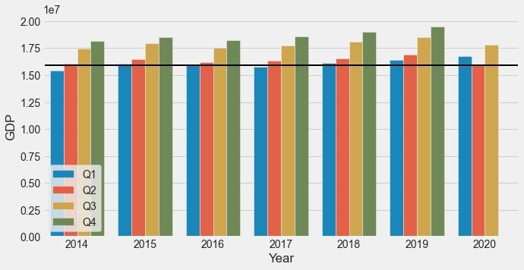

***Nigeria’s Quarterly GDP(2014-2020)***

# References

* <https://www.brookings.edu/blog/africa-in-focus/2020/04/08/understanding-the-impact-of-the-covid-19-outbreak-on-the-nigerian-economy/>
* <https://www.aljazeera.com/news/2020/11/21/nigeria-slips-into-recession-blamed-on-covid-19-and-oil-prices>
* <https://www.statista.com/statistics/1122723/impact-of-coronavirus-on-oil-price-in-nigeria/>